WCRC Paint a Plow Program

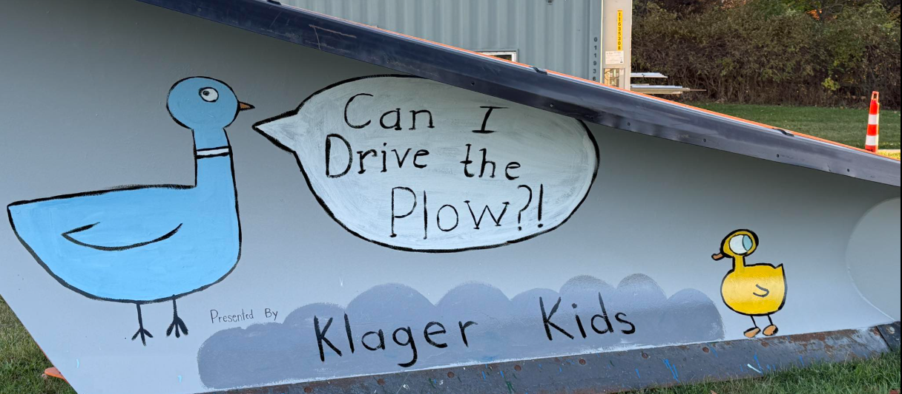
Program Details
The Washtenaw County Road Commission’s (WCRC) Paint a Plow Program is a way for local organizations to showcase their artistic talent and learn about the services WCRC provides to the community.
Organizations are invited to paint a WCRC snowplow with original artwork. The painted plows will be used on WCRC plow trucks during the winter. In addition, the plows may be used at events within the community, for example parades or touch-a-truck events depending on availability.
For more information, contact (734) 761-1500 or email wcrc@wcroads.org

Theme –
This year’s Paint-a-Plow theme is “Road Safety” with the slogan “Move Over Michigan”. Please design your plow around this theme.
Artwork must be original, non-political, non-religious and in good taste; anything deemed inappropriate will be painted over by WCRC staff.

Apply Online
Visit wcroads.org/paint-a-plow-program to submit your organization’s application to be a part of the Fall 2026 program. All applications are due by August 20, 2026.

Important Dates
Application Deadline  August 20 ,2026 | Plow drop off  September 15, 2026 | Plow pick up  October 12, 2026
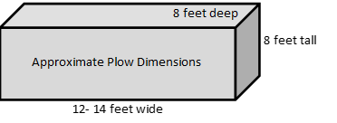

Participants
- This program is open to any school or community organization located in Washtenaw County.
- Participants will be selected based on the availability of equipment in that area.
- Staff and/or administrators may direct the selection of the design and the people to be involved; however, only students/members for the organization applying should complete the artwork.
- Artwork must be theme related.
- Artwork must be original, non-political, non-religious and in good taste; anything deemed inappropriate will be painted over by WCRC staff.

Provisions
- WCRC will deliver a clean plow, which has been primed with a gray surface, to a secure location at the organizations address, during the week of September 15, 2026, as agreed upon with staff. Parking lots or shipping bays make great location for plow storage and painting.
- Plows may not be removed from the specified location on the organization’s premises by anyone other than the WCRC.
- The structure of the plow cannot be modified in any way; there can be no addition of material including lights or ornaments.
- All plows will be picked up during the week of October 12, 2026.
- Specific arrangements for the days and times to deliver and pick up the plows will be coordinated between the host organization and WCRC staff.
- WCRC does not provide financial assistance for supplies, materials or other items associated with this program.
- Selection of paint materials to be used will be determined by the organization. Durable paint like enamel or automotive paint is recommended. A clear coat applied over the artwork is recommended to help with preservation.

Display & Promotion
- Whenever possible, during winter, painted plows will be affixed to a truck working within the county.
- It should be expected that the painted artwork on a plow will wear away once the plow is put into service during winter.
- In the event of an early snowstorm, WCRC may need to arrange an early equipment pick-up before the October deadline.
Parades
- If you would like your plow to be featured in a community parade in Washtenaw County, please note that requests will be considered on a first-come, first-served basis. Due to limited availability, we can only accommodate one organization per parade and cannot guarantee participation in every event.

